**Bezier Surfaces**

Two sets of orthogonal Bezier curves can be used to design an object surface be specifying by an input mesh of control points. The parametric vector function for the Bezier surface is formed as the Cartesian product of Bezier blending functions:

Bezier surfaces are defined by simple generalization of the curve formulation. Here, tensor product approach is used with two directions of parameterization ‘u’ and ‘v’.

Any point on the surface can be located to given values of parametric pair by

P(u,v) = $\sum_{j=0}^{m}{\sum_{k=0}^{n}{P_{j,k}{BEZ}_{j, m}\left(u\right){BEZ}_{k,n}\left(v\right)} }$ 0 ≤ u,v ≤ 1

As in the case of Bezier curves the Pj,k define the control vertices and the BEZj,m(u) and Bk,n`(v) are the Bernstein blending functions in the u and v directions

The Bézier functions specify the weighting of a particular knot. They are the Bernstein coefficients. The definition of the Bézier functions is

${BEZ}_{j, m}\left(u\right)= C(m,j){ u}^{j }{(1-u)}^{m-j}$ $${BEZ}_{k, n}\left(v\right)= C(n,k){ v}^{k }{(1-v)}^{n-k}$$

where C(m,j) represents the binomial coefficients.

$$C\left(m,j\right)=\frac{m!}{j!\left(m-j\right)!}$$

where C(n,k) represents the binomial coefficients.

$$C\left(n,k\right)=\frac{n!}{k!\left(n-k\right)!}$$

When t = 0, the function is one for j = 0 and zero for all other points.

When we combine two orthogonal parameters, we find a Bézier curve along each edge of the surface, as defined by the points along that edge.

Bézier surfaces are useful for interactive design and were first applied to car body design.

The degree of blending functions does not have to be the same in two parametric directions it could be cubic in ‘u’ and quadratic in ‘v’

The properties of Bezier surfaces are controlled by the blending functions

- The surface takes the general shape of the control points

- The surface is contained within the convex hull of the control points

- The corners of the surface and the corner control vertices are coincident

Two sets of orthogonal Bezier curves can be used to design an object surface by specifying by an input mesh of control points.

The parametric vector function for the Bezier surface is formed as the Cartesian product of Bezier blending functions with Pj,kspecifying the location of the ( m + 1) by ( n + 1)control points.

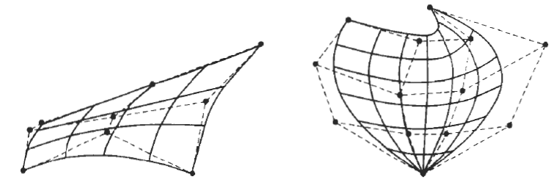

Bezier surfaces constructed for m = 3 n = 3 and m = 4 n = 4

Dashed lines connect the control points

